Bryan Vuong

BUS 4-112 Section 2

Professor Ashraf Shirani

10/10/2020

Query #1

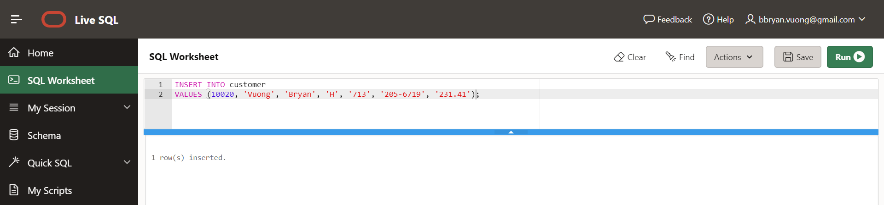

Query #2

